**ABSTRACT**

Facial features can be extracted and measured, calculated and analyzed to detect the various moods of a person. This helps us to maintain the mental health of users and suggest various solutions to the problem of increasing workload. Facial expression recognition can be integrated within an application to achieve a healthy workplace with efficient users. This proposed work proposes a tool that uses facial expressions to detect the various moods of the user and recommend distribution of workload. Primarily, an image is captured after certain time intervals through an image capturing device. This captured image works as an input to the system. The image then, goes through pre-processing that includes noise elimination and grayscale conversion. The face will then be detected using Viola Jones algorithm. Hybrid CNN will then work to identify the features like nose, eyes, lips, jawline from the detected face. The identified features will then be mapped to the features in the database and CNN classifier will be used to classify the facial expression. At the end, proposed solution will be generated showing the identified facial expression and recommendations for workload distribution.

**Keywords**- Image Pre-processing, Grayscale conversion, Viola Jones algorithm, Hybrid CNN, Mapping features, CNN classifier

**CHAPTER 1: INTRODUCTION**

In today’s competitive world, the pressure on working employees and students has increased extremely. This results in an increase in stress levels of the working class and deterioration of their mental health. Due to increased workload, there is an increase in accidents and loss of absenteeism of employees causes financial loss to organizations. The detection of facial expressions will help to detect the stress levels of the user and take remedial actions over it. This tool will help in maintaining a healthy workplace environment and increase work productivity and efficiency of companies. The only challenge standing in the way of this tool’s performance is being able to accurately detect and recognize the facial expressions.

* 1. **AIMS**
* Learn Python programming language for building software
* Understand and learn the use of OpenCV2 library for image processing
* Study working of Viola Jones, Hybrid CNN and CNN classifier algorithms
  1. **GOALS**
* To capture images after certain time intervals through an image capturing device
* To eliminate noise from captured image and convert it to grayscale
* To accurately detect face and identify features
* To recognize the facial expressions and classify them accordingly
* To generate an output report in form of bar graph and pie chart
  1. **SOFTWARE DEVELOPMENT MODEL**

The software development model used for developing this project is Waterfall model. As the Waterfall model is linear, it proved perfectly applicable for the project development as it is a small project and the scope and requirements of this project can be varied. The first two phases i.e. Requirement analysis and System design have been completed and the development is in the third phase which is Implementation. A specific set of basic requirements have been defined and various analysis and design models have been constructed that forms the very base of implementation phase. The implementation is being carried out in the form of modules to conveniently develop, integrate and test the software.

System Design

Requirement Analysis

Implementation

Deployment

Testing

Maintenance

Fig.1 Phases of Waterfall Model

**CHAPTER 2: BACKGROUND**

**2.1 LITERATURE SURVEY**

|  |  |  |  |  |
| --- | --- | --- | --- | --- |
| Sr. No | Title | Publication and Year | Algorithm | Advantage |
| 1 | Facial parts detection using Viola Jones algorithm | IEEE 2017 | Viola Jones | Good decision rates in real time |
| 2 | Face detection based on Skin color and Adaboost algorithm | IEEE 2017 | Skin Color with AdaBoost | Faster speed of face detection with high accuracy and reduced error rate |
| 3 | A face detection algorithm based on Adaboost and new Haar-like feature | IEEE 2016 | New Haar-Like classifier | Higher face detection rate and lower false detection rate |
| 4 | The face detection algorithm based on local elastic potential energy feature | IEEE 2017 | Local Elastic Potential Energy Feature | Improved accuracy and robust to rotation and scaling transformation |
| 5 | Recognition of face orientation by Divided Hausdorff distance | IEEE 2015 | Divided Hausdorff Distance | Better face orientation recognition |
| 6 | Robust Face Detection using Convolutional Neural Network | IJCA 2015 | Viola Jones-Gabor-CNN classifier | Efficient and accurate facial expression recognition |
| 7 | Features Extraction For Facial Expressions Recognition | IEEE 2016 | ACM | Relatively insensitive to noise |
| 8 | Feature Detection and Tracking with Constrained Local Models | IEEE 2015 | CLM | Simple, efficient and robust |
| 9 | An improved active shape model method for facial  landmarking based on relative position feature | IEEE 2015 | ASM | Faster and achieves more accurate feature point location |
| 10 | Features Extraction For Facial Expressions Recognition | IEEE 2016 | AAM | Build a convincing model with a small number of landmarks -Give a better match to the image texture |
| 11 | Conference on Computer Vision and Pattern Recognition (CVPR) | IEEE 2015 | Hybrid - CNN | Automatically extracts the salient features of the input image |

Table. 1 Literature Survey of various algorithms

**Summary of Literature Survey:**

The above literature survey gives various methods that can be used for face detection and facial feature extraction. It gives the advantages of each method. One may use the method based on the requirements. A main advantage of these methods is that they can be combined with various classifier to form hybrid methods. For face detection, the Viola Jones algorithm is a better algorithm as compared to others because it has highest accuracy, is easy to implement and is faster. For facial feature extraction, the method using Hybrid CNN is most advantageous as it automatically extracts the salient features of the input image. In order to classify the extracted facial features, we can use the CNN multi-classifier to classify the acquired results into different human emotions.

**2.2 PROJECT WORK**

Primarily, the entire development phase of the software was broken down into modules like face detection, face recognition, facial feature extraction and classification of human emotions. An extensive research was carried out to find out the various algorithms available for each module.

Later, all those algorithms and methodologies were studied to understand individual working and their advantages and disadvantages were noted down. A comparison of all the existing algorithms was made to figure out the best suited algorithm for each module. The factors such as processing time, accuracy, efficiency, throughput were taken into consideration to choose the best suited algorithms.

After the different algorithms were chosen, it was mandatory to study the various tools, libraries and frameworks required to implement respective algorithms. The main programming language for the software development was chosen later on the basis of the ease of implementation and higher number of libraries provided. This is how the project work was carried out to learn about the methodology used for investigation of the problem.

**2.3 ALGORITHMS / SOFTWARES USED**

1. Viola Jones Algorithm (Haar-Cascade classifier) for face detection
2. Hybrid CNN for feature identification and extraction
3. CNN classifier for classification of facial expressions

**2.4 LIBRARIES USED**

1. cv2
2. numpy
3. imutils
4. fpdf
5. keras.models – load_model

**CHAPTER 3: SPECIFICATION**

**3.1 PROBLEM STATEMENT**

The pressure on working employees and students has increased extremely. This results in an increase in stress levels of the working class and deterioration of their mental health. Due to increased workload, there is an increase in accidents and loss of absenteeism of employees causes financial loss to organizations. The detection of facial expressions will help to detect the stress levels of the user and take remedial actions over it. This tool will help in maintaining a healthy workplace environment and increase work productivity and efficiency of companies.

**Concise Problem Definition:** A recommendation tool for workload distribution using facial expressions.

**3.2 MODULES**

The entire project has been divided into 7 modules. They are as follows –

1. Image capturing via webcam and pre-processing
2. Face detection
3. Training model
4. Face Recognition
5. Identification and extraction of features
6. Classification of facial expressions
7. Generation of report in form of bar graph and pie chart

**3.3 REQUIREMENTS SPECIFICATION**

The structured list of requirements to be met by the developed software is as follows-

1. To be able to capture images after random time intervals.
2. To eliminate the noise from captured images and convert it to grayscale.
3. To accurately detect presence of human face from the image.
4. To recognize face from detected face.
5. To be able to identify and extract the features of the face.
6. To classify the facial expressions as happy, scared, angry, disgusted.
7. To generate a report describing the mood of the user and recommendations for workload distribution.

**3.4 HARDWARE REQUIREMENTS**

The hardware requirements are as follows-

* Processor – i5 and above
* RAM – 4 Gigabytes and above
* Graphics card
* Webcam

**3.5 SOFTWARE REQUIREMENTS**

* Operating system – Ubuntu, Windows 8 and above
* OpenCV installed
* Python 3.2.7 and above

**3.6 USE CASE DESCRIPTION**

|  |  |
| --- | --- |
| Name | Facial expression detection |
| Description | This use case allows system to capture images of the user to detect and recognize the face and extract its facial features to classify the facial expressions of the user efficiently |
| Actors | User, Manager, System |
| Frequency of Use | Approximately 8-10 times a day |
| Pre-condition | The machine should be turned ON by the user and should be running |
| Post-condition | System should accurately classify the detected facial expression |
| Main flow | 1. User turns the machine on. 2. System starts the webcam. 3. Captures images after random intervals. 4. Detects face from captured image. 5. Converts to pixels and maps features. 6. Classifies the features into facial expressions. 7. System generates output report. 8. Manager analyses the generated report |

Table. 2 Use Case Description

**CHAPTER 4: DESIGN**

**4.1 BLOCK DIAGRAM**

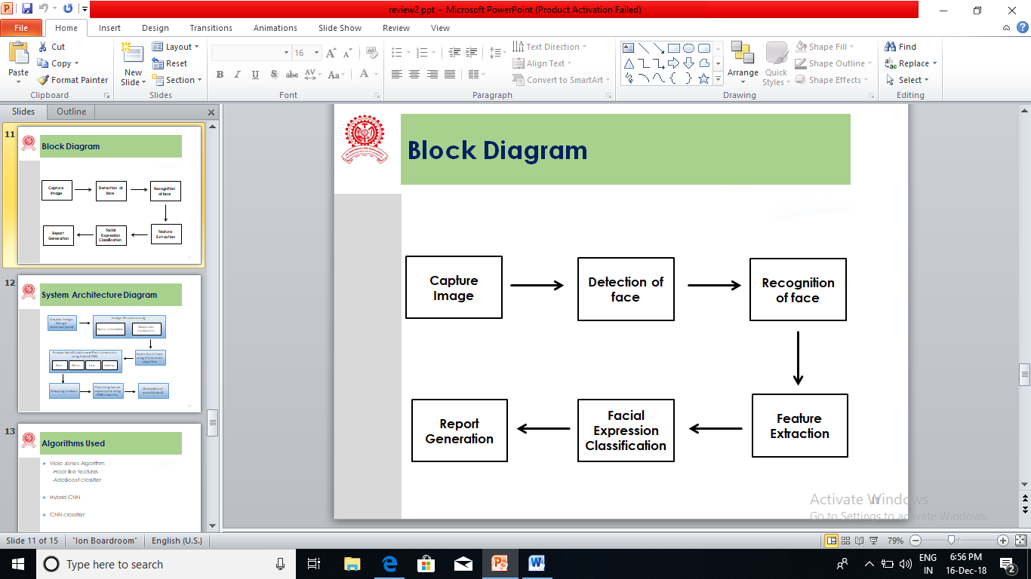

Fig. 2 Block Diagram

**4.2 SYSTEM ARCHITECTURE**

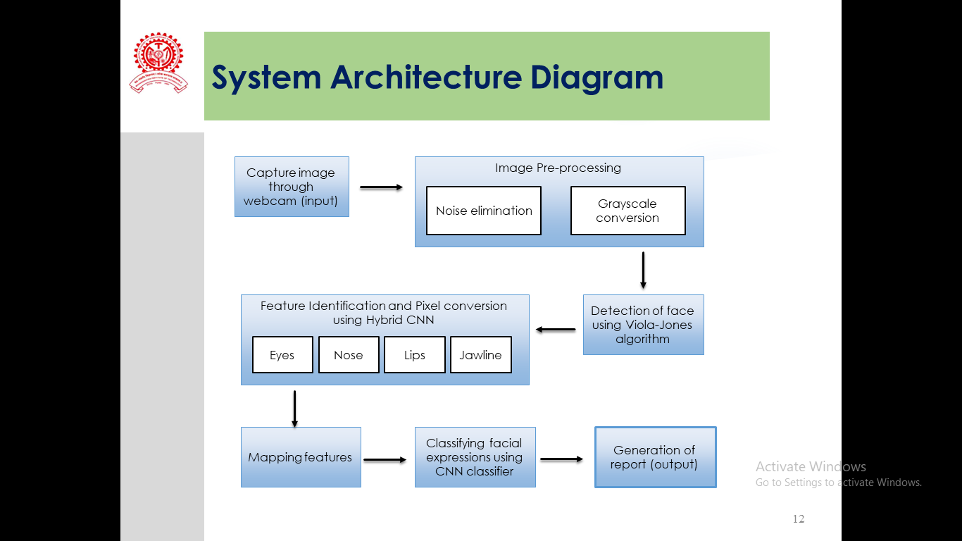

Fig. 3 System Architecture

**4.3 DATAFLOW DIAGRAM**

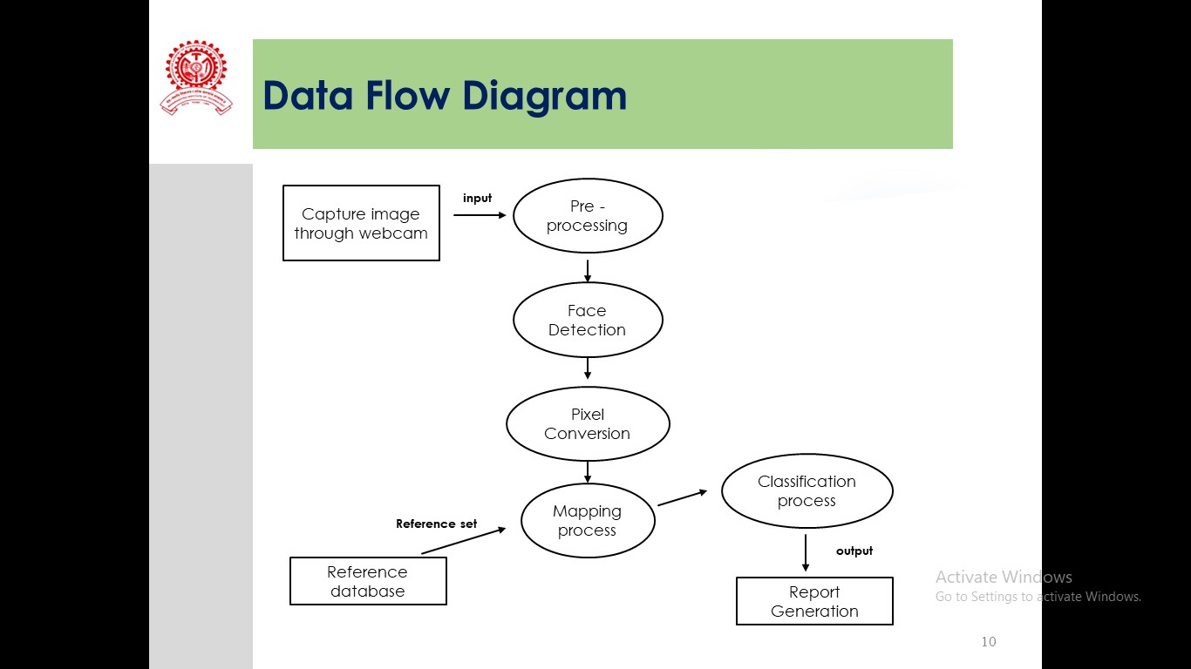

Fig. 4 Data Flow Diagram

**4.4 USE CASE DIAGRAM**

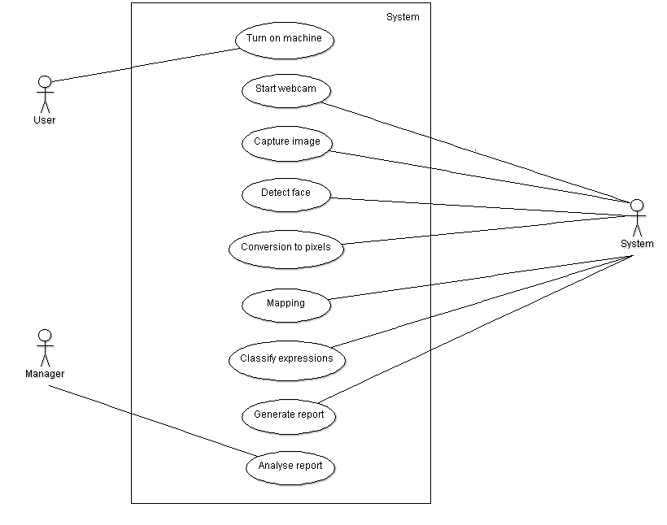

Fig. 5 Use Case Diagram

**4.5 ACTIVITY DIAGRAM**

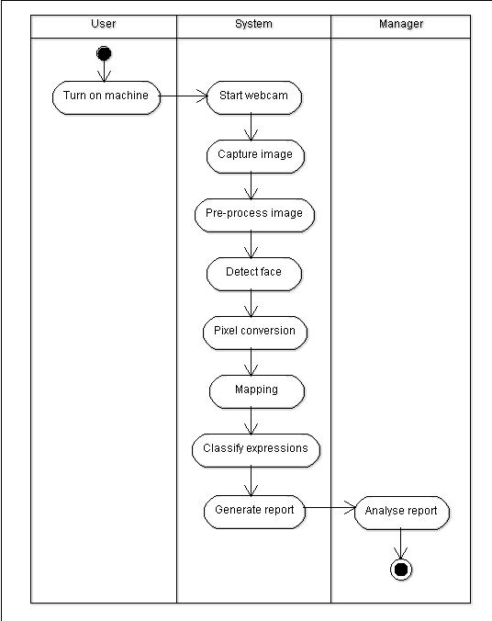

Fig. 6 Activity Diagram

**4.6 STATE DIAGRAM**

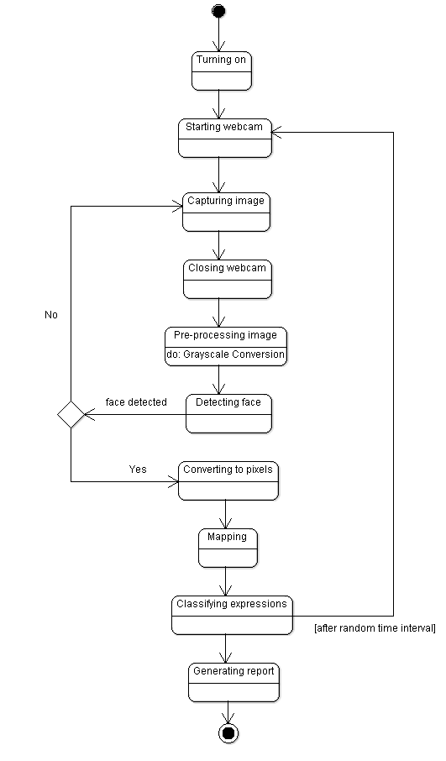

Fig. 7 State Diagram

**4.7 CLASS DIAGRAM**

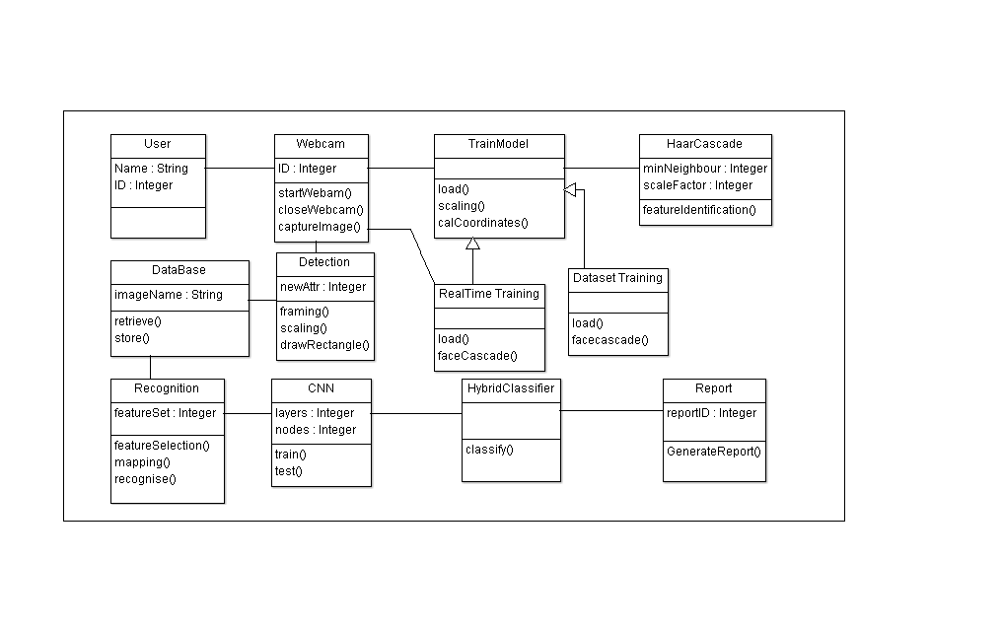

Fig. 8 Class Diagram

**CHAPTER 5 : PLANNING AND SCHEDULING**

|  |  |
| --- | --- |
| **Month and Year** | **Description** |
| July 2018 | Requirement Gathering |
| August 2018 | Survey of different methodologies |
| September 2018 | Finding proper dataset for facial expression recognition |
| October 2018 | Dataset Generation for recognition |
| November 2018 | Training of different models |
| December 2018 | Training of different models |
| January 2019 | Development of detection module |
| February 2019 | Development of recognition module |
| March 2019 | Expression classification module |
| April 2019 | Integration Testing |
| May 2019 | System Testing |

Table 3. Planning Activities

**CHAPTER 6: IMPLEMENTATION**

**6.1 MODULE DESCRIPTION**

**1. Image capturing via webcam and pre-processing**

An image capturing device like webcam will capture images after random time intervals and pre-process the captured images. The pre-processing of the image includes two steps – noise elimination and grayscale conversion. Images are captured using the function cv2.VideoCapture(). The RGB image is converted to grayscale for better processing. Real time images will be captured in burst format for higher accuracy. To convert RGB images to grayscale, we use the function COLOR_BGR2GRAY.

**2. Face Detection**

The pre-processed images are given as input to this module to detect the presence of human face in the captured image. Viola Jones algorithm is used in this module that includes Haar and Cascade classifiers that work by training the cascade on thousands of negative images with the positive image superimposed on it to detect the face efficiently. The haarcascade_frontalface_default xml is a haar cascade designed by OpenCV to detect the frontal face. The Cascade classifier detectMultiScale detects objects of different sizes in the input image. The detected objects are returned as a list of rectangles.

**3. Training Model**

In CNN, keras model is used in which dropout is a regularization technique for neural network models. Dropout is only used during the training of a model and is not used when evaluating the skill of the model. In our model, we have set dropout value to 0.5.

In keras, the input layer itself is not a layer, but a tensor. It's the starting tensor we send to the first hidden layer. This tensor must have the same shape as our training data. Since our training data contains 48x48 images, our input shape has 48x48 parameter. A bounding box is drawn accordingly and Relu is the activation function used for input hidden layers. The activation function used for output is Softmax. The number of classes in model is 7 and it saves only the best models and returns them.

**4. Face Recognition**

After the models have been trained and the best suitable model been found, we perform face recognition on the already detected faces by using an ID entered by the user, the first time his face images are captured by the system. All face recognition models in OpenCV are derived from the abstract base class FaceRecognizer, which provides a unified access to all face recongition algorithms in OpenCV.

OpenCV has three built-in face recognizers out of which we make use of Local Binary Patterns Histogram graphs (LBPH) – cv2.face.createLBPHFaceRecognizer(). The input to this face recognizer are the set of grayscale images that are stored in array format. Eigenfaces and Fisherfaces are both affected by light and, in real life, we can't guarantee perfect light conditions. LBPH face recognizer is an improvement to overcome this drawback.

Cv:: Algorithm

Cv::face:: FaceRecognizer

Cv::face::BasicFaceRecognizer

Cv::face:LBPHFaceRecognizer

Cv::face::FisherFaceRecognizer

Cv::face:EigenFaceRecognizer

Fig 9. Inheritance diagram for cv::Face::FaceRecognizer

**5. Identification and extraction of features**

The output from face detection module is given to this module. In this module, Hybrid CNN is used to identify the different features of the face. The functions used to detect the face and its features are scaleFactor(), minNeighbors() and minSize().

scaleFactor() - The value indicates how much the image size is reduced at each image scale. A lower value uses a smaller step for downscaling. This allows the algorithm to detect the face. It has a value of x.y, where x and y are arbitrary values we can set.

minNeighbors() - This parameter specifies how many “neighbors” each candidate rectangle should have. A higher value results in less detections but it detects higher quality in an image. We can use a value of X that specifies a finite number.

minSize() - It is the minimum object size. By default it is (30,30). The smaller the face in the image, it is best to adjust the minSize value lower.

**6. Classification of facial expressions**

This process starts from three sequential convolutional layers followed by a max-pooling layer, common activation function for convolutional layer "Relu" is used, as well as the same padding pattern. Then, from the basic structure, we further added more and more convolutional layers with different features captured.

The features to be captured from convolutional layer increased from 32 to 128, such hierarchical structure with increasing layer nodes performs better for deep neural network. Finally, the convolved layer is first flattened and then go through two more dense layers to reach the output layer in which Softmax activation function is used for multiclass classification which is seven classes in total.

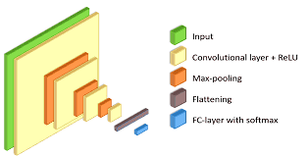

Fig 10. Structure of CNN model [11]

**7. Generation of report**

The classified emotions are given occurrence percentages and percentages of the probabilities are averaged. These average percentages are categorized emotion wise in each session. At the end of the session, a pie chart and bar graph is created. These statistical graphical analytic reports are available to be viewed by the administrator through a web portal.

Along with the analytic reports, the recommended flow of workload is also suggested. The flow of workload is decided on the percentage level of stress emotion. The workflow levels are LOW, NORMAL and HIGH.

|  |  |  |
| --- | --- | --- |
| **Sr. No.** | **Threshold Range Value (%)** | **Resultant Inference** |
| 1 | 0 - 15 | HIGH |
| 2 | 16 – 25 | NORMAL |
| 3 | > 25 | LOW |

Table 4. Threshold range values of stress for inference

**6.2 CODE SNIPPET**

**real_time_video.py**

# parameters for loading data and images

detection_model_path = 'haarcascade_files/haarcascade_frontalface_default.xml'

emotion_model_path = 'models/_mini_XCEPTION.102-0.66.hdf5'

# hyper-parameters for bounding boxes shape

# loading models

face_detection = cv2.CascadeClassifier(detection_model_path)

emotion_classifier = load_model(emotion_model_path, compile=False)

EMOTIONS = ["Angry" ,"Disgust","Scared", "Happy", "Stress", "Surprised",

"Neutral"]

recognizer = cv2.face.LBPHFaceRecognizer_create()

recognizer.read('/home/pratik/Desktop/Face-Recognition-master/trainer/trainer.yml')

cascadePath = '/home/pratik/Desktop/Face-Recognition-master/Classifiers/face.xml'

faceCascade = cv2.CascadeClassifier(cascadePath);

font = cv2.FONT_HERSHEY_SIMPLEX

#feelings_faces = []

#for index, emotion in enumerate(EMOTIONS):

# feelings_faces.append(cv2.imread('emojis/' + emotion + '.png', -1))

# starting video streaming

cv2.namedWindow('your_face')

camera = cv2.VideoCapture(0)

while True:

frame = camera.read()[1]

#reading the frame

frame = imutils.resize(frame,width=600,)

gray = cv2.cvtColor(frame, cv2.COLOR_BGR2GRAY)

faces=face_detection.detectMultiScale(gray,scaleFactor=1.1,minNeighbors=5, minSize= (30,30),flags=cv2.CASCADE_SCALE_IMAGE)

canvas = np.zeros((350, 500, 3), dtype="uint8")

frameClone = frame.copy()

if len(faces) > 0:

faces = sorted(faces, reverse=True,

key=lambda x: (x[2] - x[0]) * (x[3] - x[1]))[0]

(fX, fY, fW, fH) = faces

# Extract the ROI of the face from the grayscale image, resize it to a fixed 28x28 pixels, and then prepare

# the ROI for classification via the CNN

roi = gray[fY:fY + fH, fX:fX + fW]

roi = cv2.resize(roi, (64, 64))

roi = roi.astype("float") / 255.0

roi = img_to_array(roi)

roi = np.expand_dims(roi, axis=0)

preds= emotion_classifier.predict(roi)[0]

nbr_predicted, conf = recognizer.predict(gray[fY:fY+fH,fX:fX+fW])

emotion_probability = np.max(preds)

label = EMOTIONS[preds.argmax()]

happy_var=0

stress_var=0

surp_var=0

dis_var=0

angry_var=0

scared_var=0

neutral_var=0

happy_count=0

stress_count=0

surp_count=0

dis_count=0

angry_count=0

scared_count=0

neutral_count=0

for (i, (emotion, prob)) in enumerate(zip(EMOTIONS, preds)):

# construct the label text

text = "{}: {:.2f}%".format(emotion, prob * 100)

if emotion == "Stress":

stress_count+=1

stress_var=(stress_var+prob)*100

if emotion == "Happy":

happy_count+=1

happy_var=(happy_var+prob)*100

if emotion == "Scared":

scared_count+=1

scared_var=(scared_var+prob)*100

if emotion == "Angry":

angry_count+=1

angry_var=(angry_var+prob)*100

if emotion == "Neutral":

neutral_count+=1

neutral_var=(neutral_var+prob)*100

if emotion == "Surprised":

surp_count+=1

surp_var=(surp_var+prob)*100

if emotion == "Disgust":

dis_count+=1

dis_var=(dis_var+prob)*100

#print('Your prob ' + text)

# draw the label + probability bar on the canvas

# emoji_face = feelings_faces[np.argmax(preds)]

w = int(prob * 300)

cv2.rectangle(canvas, (7, (i * 35) + 5),

(w, (i * 35) + 35), (238, 118, 0), -1)

cv2.putText(canvas, text, (10, (i * 35) + 23),

cv2.FONT_HERSHEY_SIMPLEX, 0.45,

(255,255,255), 2)

cv2.putText(frameClone, "Id:"+str(nbr_predicted)+" "+label, (fX, fY - 10),

cv2.FONT_HERSHEY_SIMPLEX, 0.45, (0, 0, 255), 2)

cv2.rectangle(frameClone, (fX, fY), (fX + fW, fY + fH),

(0, 0 ,255 ), 2)

# for c in range(0, 3):

# frame[200:320, 10:130, c] = emoji_face[:, :, c] * \

# (emoji_face[:, :, 3] / 255.0) + frame[200:320,

# 10:130, c] * (1.0 - emoji_face[:, :, 3] / 255.0)

cv2.imshow('USER_FACE', frameClone)

cv2.imshow("Probabilities", canvas)

if cv2.waitKey(1) & 0xFF == ord('q'):

break

stress_per=stress_var/stress_count

happy_per=happy_var/happy_count

dis_per=dis_var/dis_count

surp_per=surp_var/surp_count

neutral_per=neutral_var/neutral_count

angry_per=angry_var/angry_count

scared_per=scared_var/scared_count

total=stress_per+happy_per+dis_per+surp_per+angry_per+neutral_per+scared_per

stress_val=(stress_per/total)

print('avg levels')

print(stress_var/stress_count)

print(happy_var/happy_count)

print(dis_var/dis_count)

print(surp_var/surp_count)

print(angry_var/angry_count)

print(neutral_var/neutral_count)

print(scared_var/scared_count)

ts = datetime.datetime.now().timestamp()

path='/home/pratik/Desktop/Emotion-recognition-master/results/'

pdf_path='/home/pratik/Desktop/Emotion-recognition-master/reports/'

y_pos = np.arange(len(EMOTIONS))

performance = [angry_per,dis_per,scared_per,happy_per,stress_per,surp_per,neutral_per]

plt.bar(y_pos, performance, align='center', alpha=0.5)

plt.xticks(y_pos, EMOTIONS)

plt.ylabel('Level')

plt.title('Emotion Level Session Graph ')

#plt.show()

#plt.pause(10)

#plt.close()

plt.savefig(os.path.join(path + str(ts)+'.png'))

plt.pie(performance, labels=EMOTIONS, startangle=90, autopct='%.1f%%')

plt.title('Emotion Chart')

plt.savefig(os.path.join(path + str(ts)+'pie.png'))

work_flow="LOW"

if stress_per <= 15.0:

work_flow="HIGH"

elif stress_per > 15 and stress_per <= 25:

work_flow="NORMAL"

else:

work_flow="LOW"

pdf = FPDF()

pdf.add_page()

pdf.ln(5)

pdf.set_font("Arial", size=16)

pdf.cell(200, 10, txt="{}".format("Analysis Report of the Session"), ln=1)

pdf.image((path + str(ts)+'.png'), x=30, y=25, w=130)

pdf.image((path + str(ts)+'pie.png'), x=30, y=130, w=130)

pdf.set_font("Arial", size=12)

pdf.ln(200) # move 85 down

pdf.cell(200, 10, txt="{}".format("Findings of the session:"), ln=1)

pdf.ln(5) # move 85 down

pdf.cell(200, 10, txt="{}".format("Workload Flow Recommendation: "+ work_flow ), ln=1)

pdf.output((pdf_path+str(ts)+".pdf"))

camera.release()

cv2.destroyAllWindows()

**6.3 SCREENSHOTS**

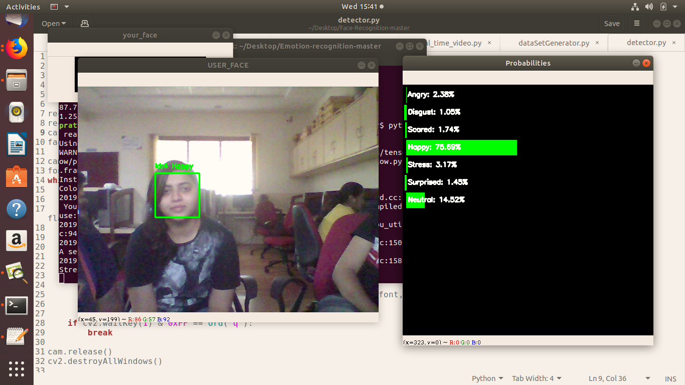

Fig 11. Capturing images via webcam while detecting face

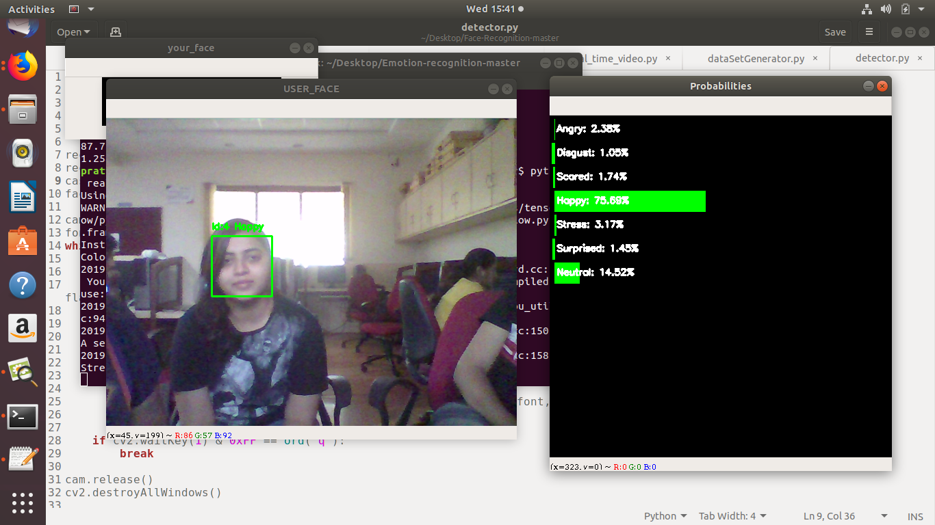

Fig 12. Probabilities of real time emotions being classified

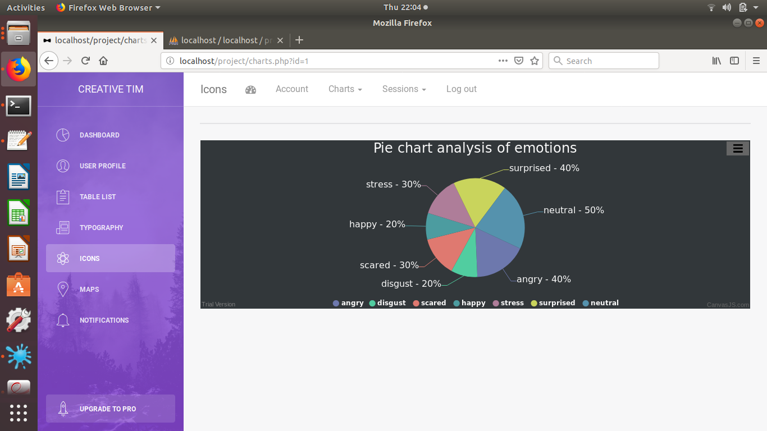

Fig 13. Generated pie chart on admin’s web portal

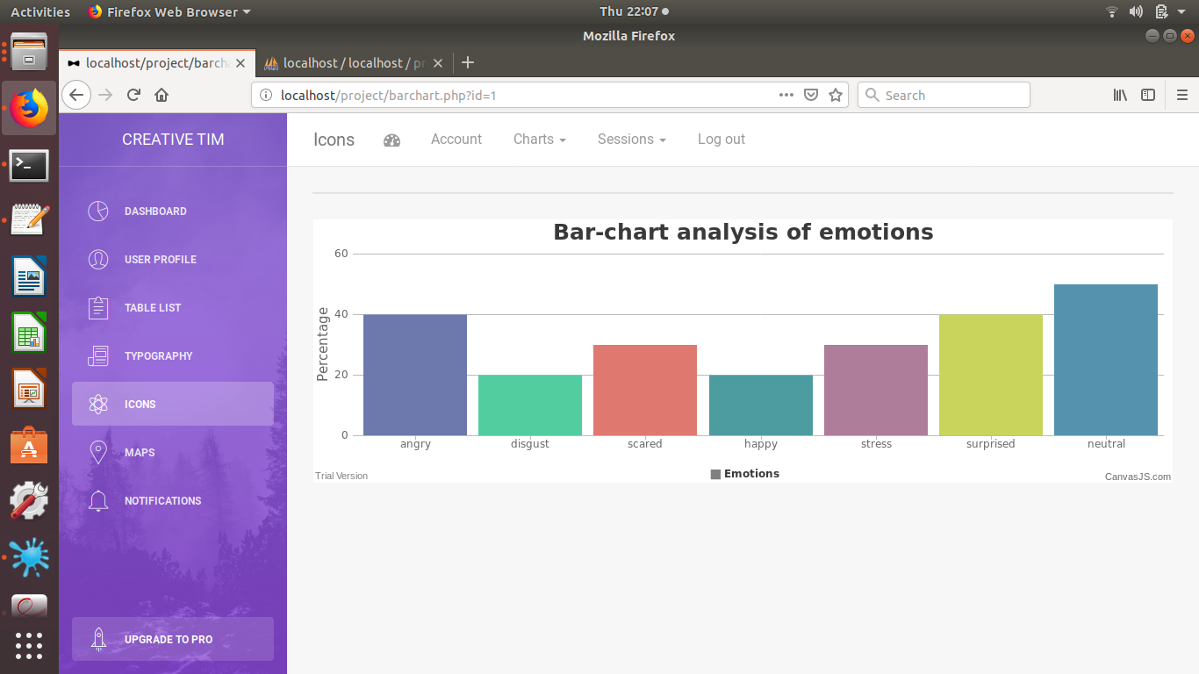

Fig 14. Generated bar graph on admin’s web portal

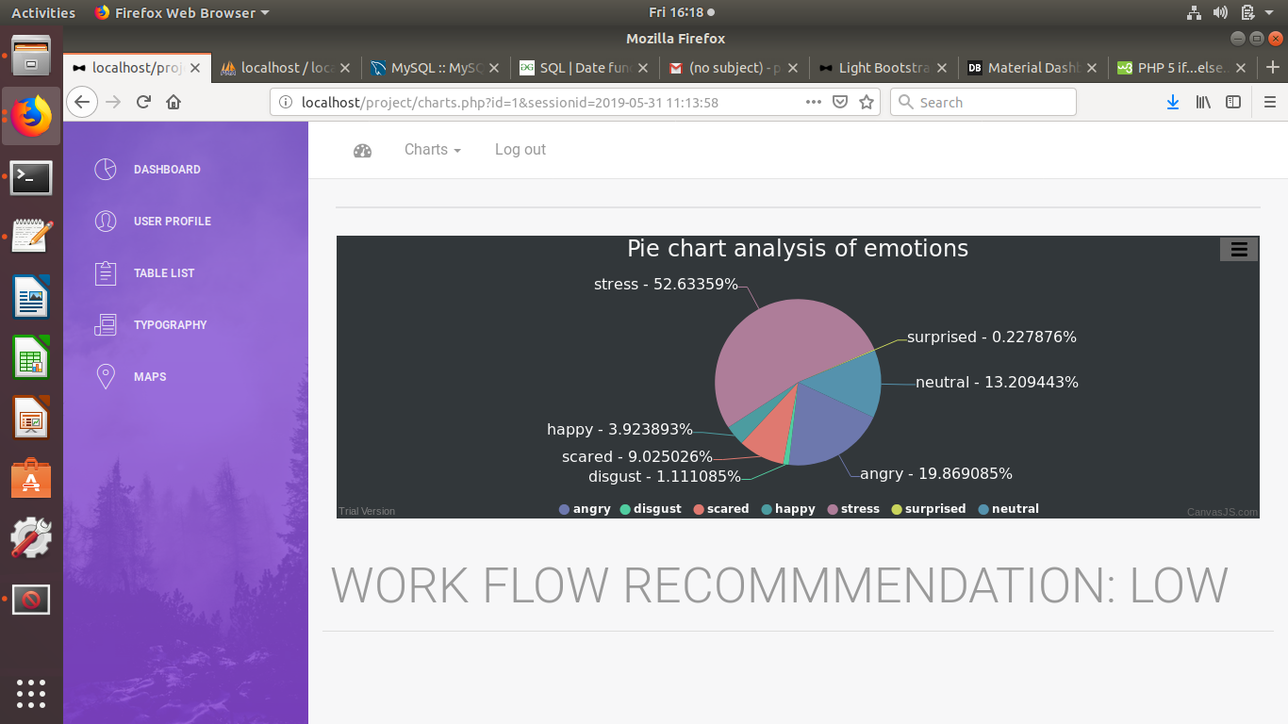

Fig 15. Workload flow recommendation

**CHAPTER 7: PERFORMANCE EVALUATION AND TESTING**

**7.1 DATASET**

FER2013 dataset was published on International Conference on Machine Learning (ICML) 6 years ago to recognize the facial expressions. FER2013 is an open-source dataset which was first created for an ongoing project by Pierre-Luc Carrier and Aaron Courville, then shared publicly for a Kaggle competition, shortly before ICML 2013.

This dataset consists of 35,887 grayscale, 48x48 sized face images with various emotions -7 emotions, all labeled. The faces have been automatically registered so that the face is more or less centered and occupies about the same amount of space in each image. The task is to categorize each face based on the emotion shown in the facial expression in to one of seven categories (0=Angry, 1=Disgusted, 2=Scared, 3=Happy, 4=Stressed, 5=Surprised, 6=Neutral).

Emotion labels in the dataset:

0: 4593 images- Angry

1: 547 images- Disgusted

2: 5121 images- Scared

3: 8989 images- Happy

4: 6077 images- Stressed

5: 4002 images- Surprised

6: 6198 images- Neutral

fer2013.csv contains two columns, "emotion" and "pixels". The "emotion" column contains a numeric code ranging from 0 to 6, inclusive, for the emotion that is present in the image. The "pixels" column contains a string surrounded in quotes for each image. The contents of this string is a space-separated pixel value in row major order.

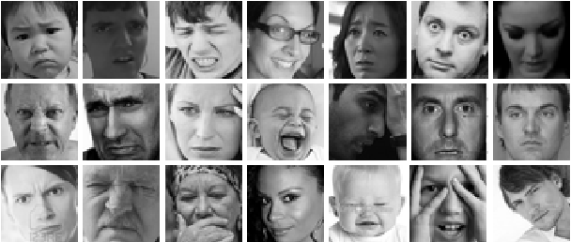

Fig 16. Example images in dataset fer2013 [10]

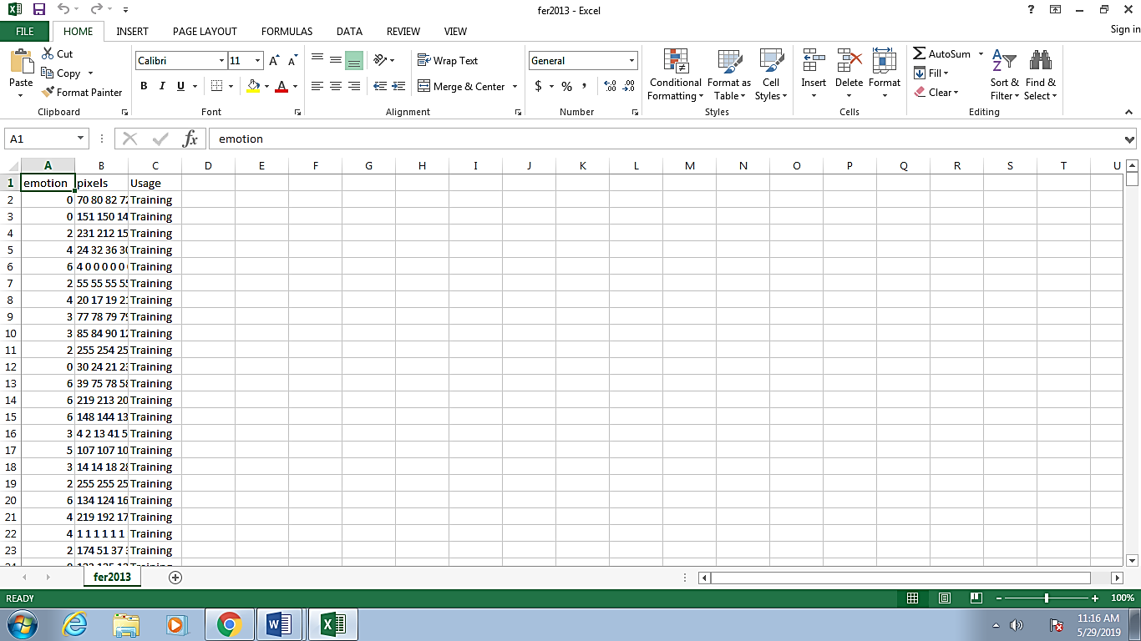

Fig 17. fer2013.csv dataset

**7.2 ACCURACY**

The dataset used has a collection of 35,887 images distributed over 7 emotions. This increases the ability of the model to detect varied range of faces and emotions. However, it has an effect on the accuracy of the model.

There are numerous models that offer accuracy range from 50% to 98%. But the models with higher accuracy have a drawback of a small set of images in database for training purpose. Therefore, we chose fer2013 dataset with a huge database and keras model of TensorFlow Backend which gives the accuracy of 76%.

The learning rate controls how quickly the model is adapted to the problem and generally has a value ranging from 0.0 to 1.0. the learning rate of our model is 0.057. One of the ways of speeding up the learning algorithm is to slowly reduce the learning rate which is called learning rate decay and has a range of 0.5 to 0.9. The learning rate decay of our model is 0.856.

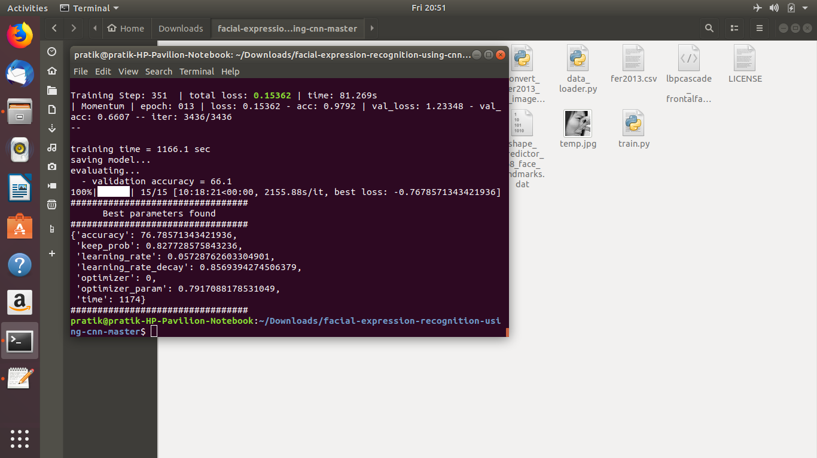

Fig 18. Trained model best parameters result

**7.3 TYPES OF TESTING PERFORMED**

Testing is an integral part of any successful software project. The types of software testing depends on various factors, including project requirements, budget, timeline, expertise, and suitability. We performed functional as well as non functional testing.

* Functional Testing

1. Unit Testing - Various units of video streaming, bounding box creation, face detection, face recognition, probability calculations, emotion classification, pie chart creation, bar graph creation were independently tested to validate that each unit of the software performs as designed.
2. Integration Testing – The individual units mentioned above were integrated with one another. Face detection and recognition modules were integrated as well as calculating probabilities of emotions and classifying them to expose faults in the interaction between integrated units.
3. Interface Testing - Along with the software, a web portal is developed and there is a server database with php connection for communication between them. The connection which integrates and facilitates the communication between these components is termed as an Interface. It verified that communication between the systems were done correctly.
4. System Testing - The complete and integrated software was tested. The purpose of this test was to evaluate the system’s compliance with the specified requirements.

* Non Functional Testing

1. Documentation Testing – Various test cases, test plans, functional requirements and design requirements were documented which helped to estimate testing efforts required and test coverage.

**7.4 Test Cases**

|  |  |  |  |  |
| --- | --- | --- | --- | --- |
| **Test Case No.** | **Test Case** | **Input** | **Desired Output** | **Actual**  **Output** |
| 1 | Initialization of camera feed | User face aligned with webcam | Camera feed starts | Camera feed was started |
| 2 | Calculation of emotion probabilities | Changing facial expressions | Probabilities of different emotions | Different percentages of emotions ere displayed |
| 3 | User smiling | User’s face | Happy label | Happy label |
| 4 | User’s face blank | User’s face | Neutral label | Neutral label |
| 5 | User’s face angry | User’s face | Angry label | Angry label |
| 6 | User’s face surprised | User’s face | Surprised label | Surprised label |
| 7 | User’s face scared | User’s face | Scared label | Scared label |
| 8 | User’s face stressed | User’s face | Stress label | Stress label |
| 9 | User’s face disgusted | User’s face | Disgusted label | Disgusted label |
| 10 | Analysis reports of user emotions | Percentages of emotions | Daily and session wise charts generate | Daily and session wise charts were generated |
| 11 | Recommendation of workload flow | Stress level percentage | High, low or normal flow suggestion | High, low or normal flow suggested |

Table 5. Test Cases

**7.5 TESTING SCREENSHOTS**

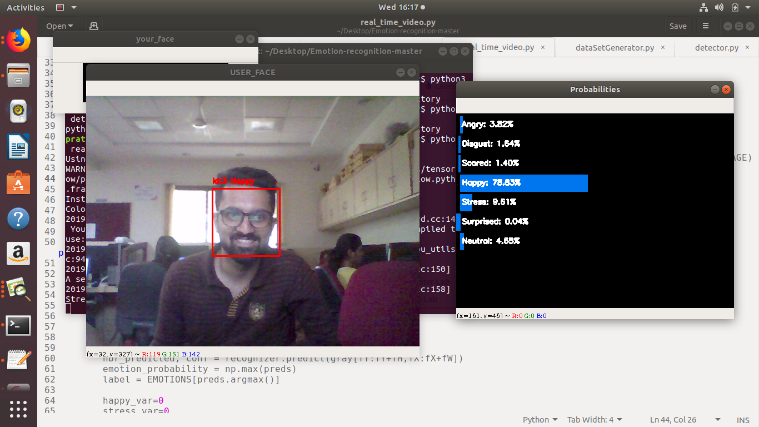

Fig 19. Camera feed initialization

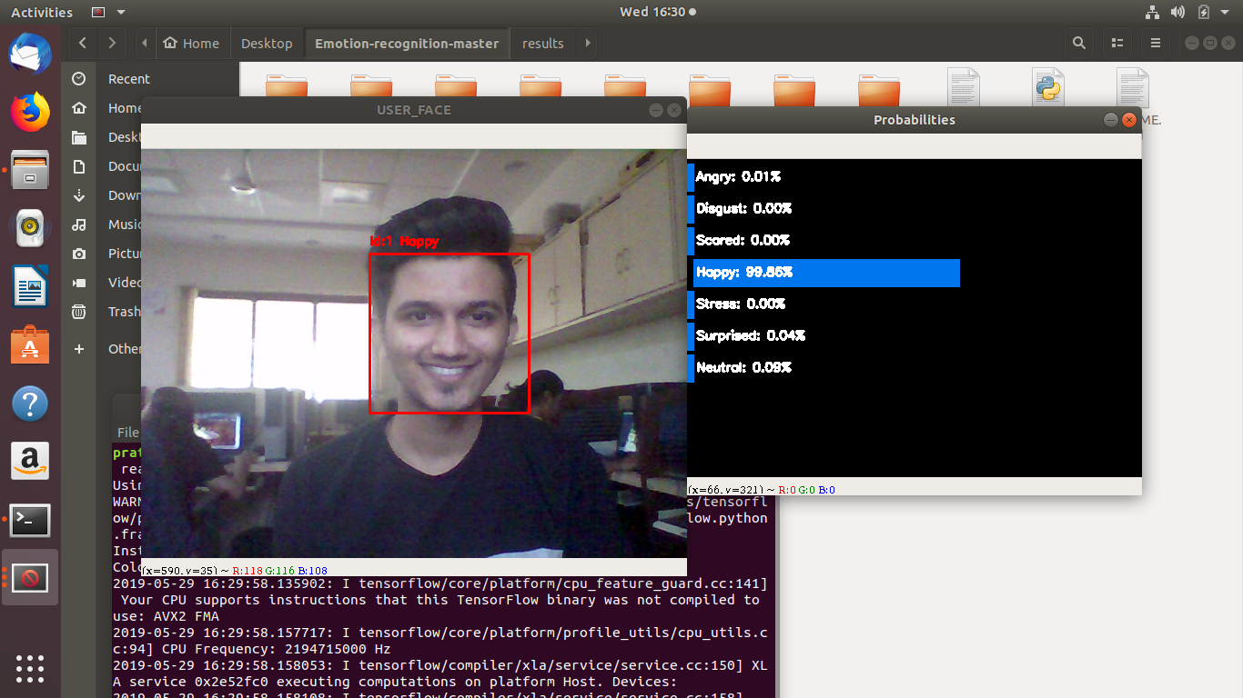

Fig 20. Happy Label

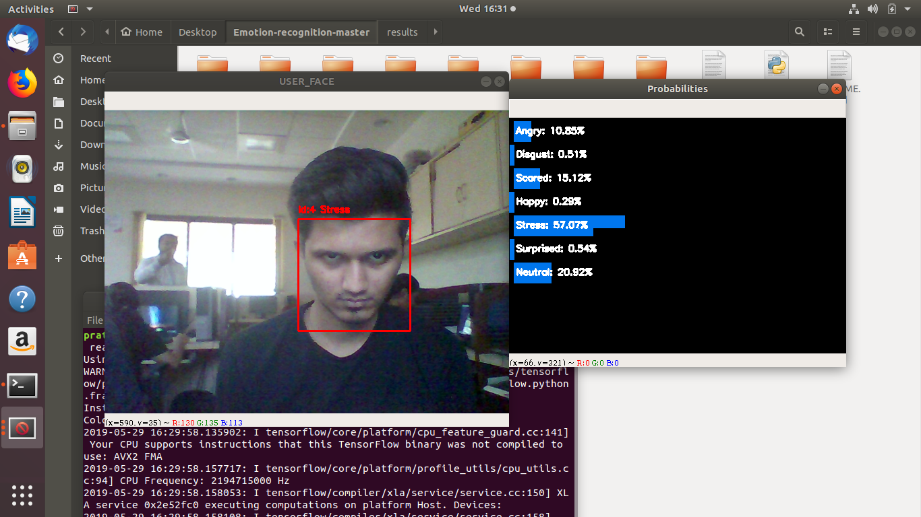

Fig 21. Stress Label

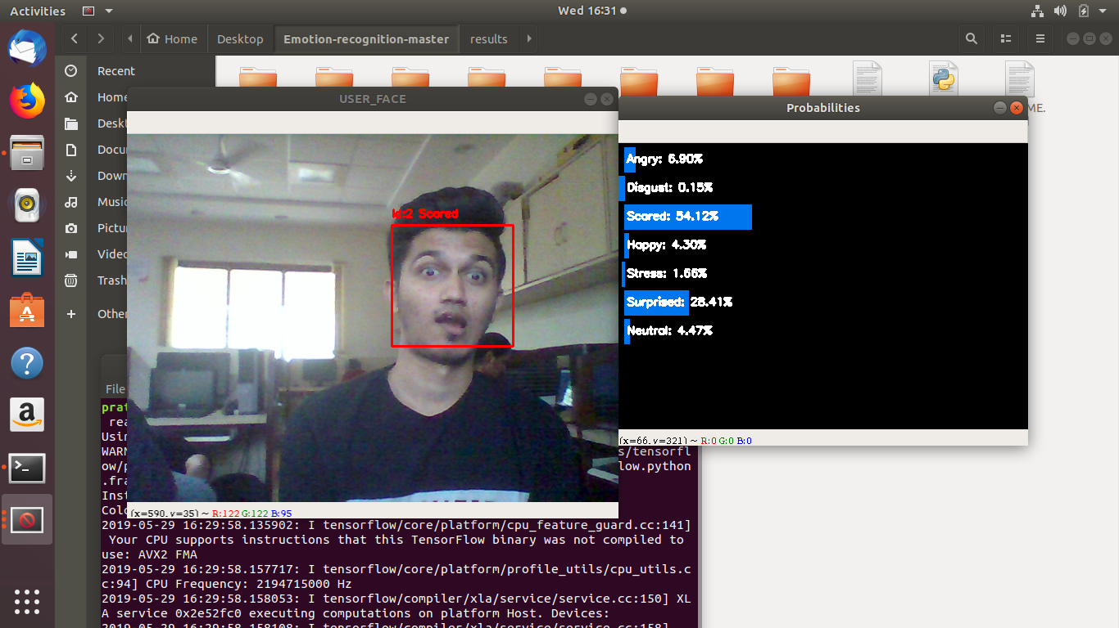

Fig 22. Scared Label

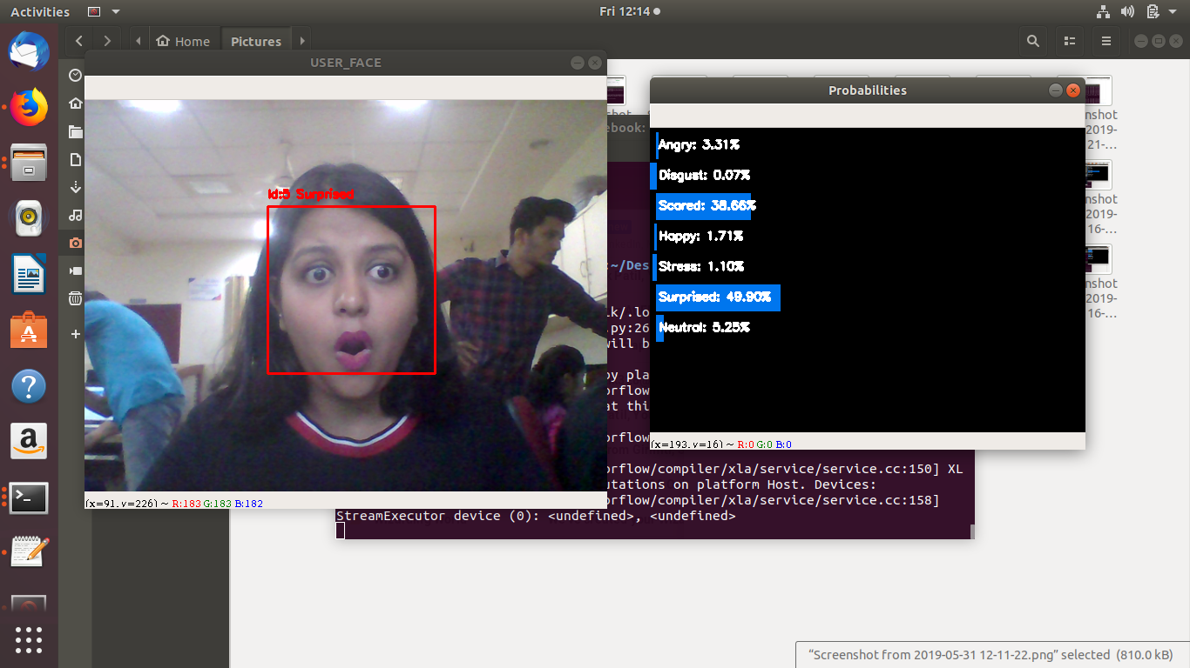

Fig 23. Surprised Label

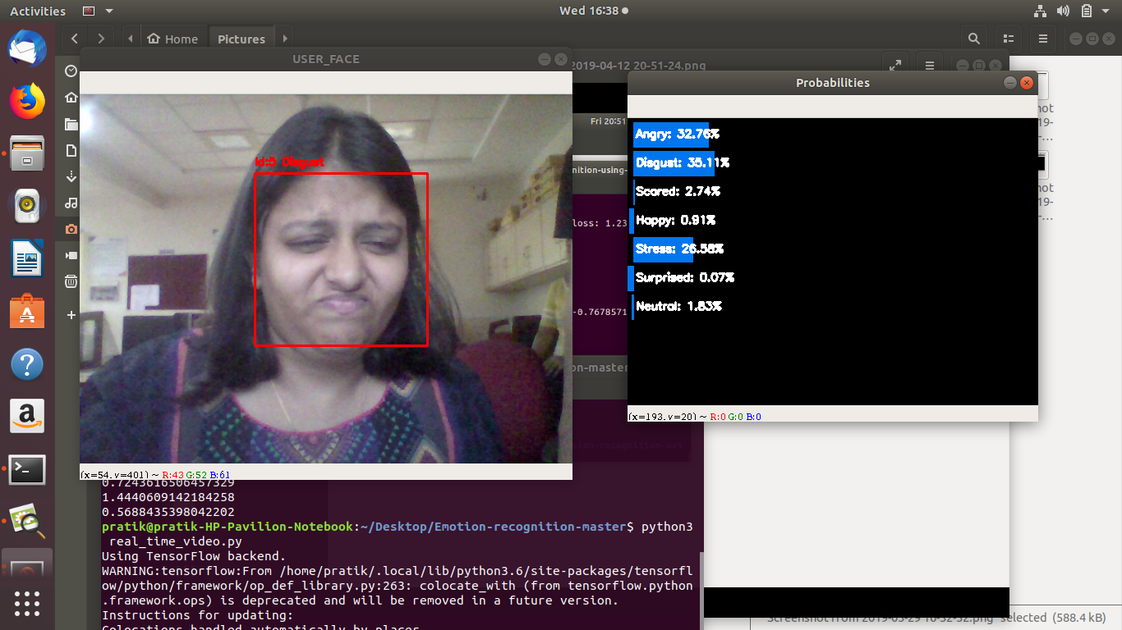

Fig 24. Disgusted Label

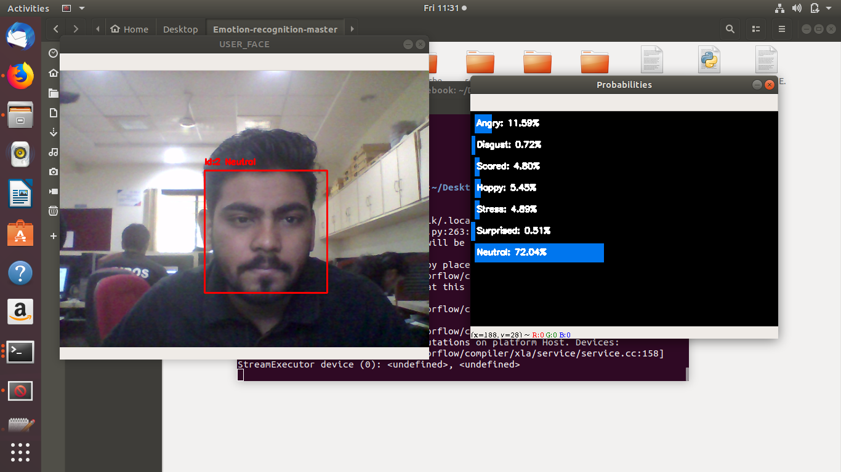

Fig 25. Neutral Label

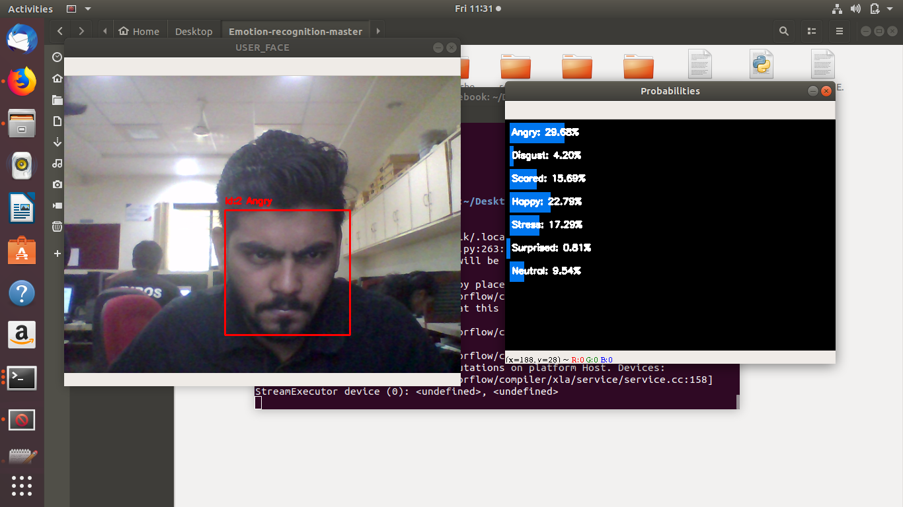

Fig 26. Angry Label

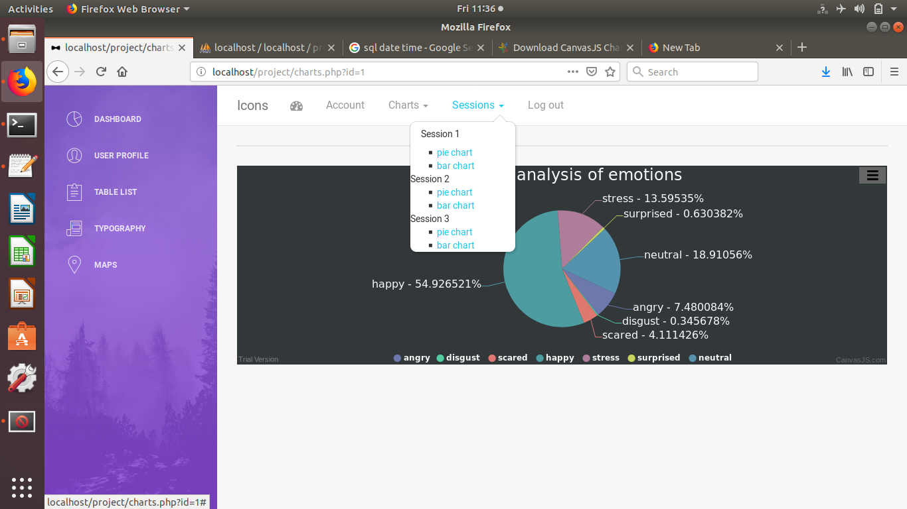

Fig 27. Session wise charts

**CHAPTER 8 : RESULT AND ANALYSIS**

The software is aimed at recommending the flow of workload efficiently. This is achieved by defining threshold range value of detected stress percentages. These percentages are calculated by multiplying them by their occurrence probabilities. Emotions are detected by the facial expressions of the user.

Steps to obtain results –

1. User should face the camera so that it starts the live camera feed.
2. Once the feed starts, user can see his face being detected and recognized with a bounding box and id.
3. The probabilities of the emotions being expressed by the user are visible on the screen.
4. After the end of the session, the probabilities are converted to percentages and are added to the server database.
5. This data in the database is sent to the web portal for the administrator to view.
6. The data to be viewed is in the form of pie charts and bar graphs.
7. These charts are categorized as Session wise and Daily Charts.
8. Based on the percentage of stress detected, the software recommends the flow of workload for the user.
9. The workload flow are of the values HIGH, NORMAL or LOW.

The analytic reports generated are easy to view and understand by the administrator.

**CHAPTER 9 : APPLICATIONS**

There are various applications in which this tool can be integrated to enhance the existing systems.

* In companies for employees – this tool can be used by HR managers in offices to monitor the various emotions and stress employees go through and accordingly manage the workload.
* In academic institutes for students – this tool can be used to monitor the various emotions the students go through during exam phases and can be enhanced to improve their performance in exams.
* In vehicles for drivers – detection of eyes can lead to examine the fatigue levels in drivers to ensure safe driving and lower accident rates.

**CONCLUSION**

This implementation concludes that the development of the software has been completed which deals with detection of the presence of human faces and extracts and classifies facial expressions from it. It computes the probabilities of the emotions and calculates occurrence percentages. These are stored in the database along with the user and session id to identify unique users and sessions. It generates an analytic report in the form of bar graph and pie chart. Based on the stress level of the user, recommendation of flow of workload is given to the administrator. The project development has followed the chosen methodology and all the requirements have been met.

**REFERENCES**

1. Anas Abouyahya, Sanaa El Fkihi, Rachid Oulad Haj Thami, Driss Aboutajdine , “Features Extraction For Facial Expressions Recognition” ,IEEE 2016

2. Chirag Ravat , Shital A. Solanki, “Survey on Different Methods to Improve Accuracy of The Facial Expression Recognition Using Artificial Neural Network”, IJSRSET 2018

3. Xiao-Xiao Niu, Ching Y.Suen, “A Novel Hybrid CNN-SVM classifier for recognizing handwriting digits”, 2011 Elsevier Ltd.

4. Hengxin Chen, Mingqi Gao, “An improved active shape model method for facial landmarking based on relative position feature”, International Journal of Wavelets, Multiresolution and Information Processing, 2017

5. Vinodpuri Rampuri Gosavi1, Dr. G. S. Sable , Dr. Anil K . Deshmane “Evaluation of Feature Extraction Techniques using Neural Network as a Classifier : A Comparative Review for face Recognition”, 2018 IJSRST

6. S L Happy, “Automatic Facial Expression Recognition Using Features of Salient Facial Patches”,IEEE 2015

7. Hongjun Wang, Jiani hu and Weihong Deng. “Face Feature Extraction: a Complete Review”,2169-3536 (c) 2017 IEEE

8. Ketki R. Kulkarni, Sahebrao B. Bagal, “Facial Expression Recognition” 2015 International Conference on Information Processing (ICIP) Vishwakarma Institute of Technology. Dec 16-19, 2015

9. Z.C.Horn ,L.Auret ,J.T.McCoy C. Aldrich, “Performance of Convolutional Neural Networks for Feature Extraction in Froth Flotation Sensing” ELSEVIER 2017

10. Christopher Pramerdorfer, Martin Kampel, “Facial Expression Recognition using Convolutional Neural Networks: State of the Art” ArXiv 2016

11. Bashir Kazimi, Frank Thiemann, Katharina Malek ,“Deep Learning for Archaeological Object Detection in Airborne Laser Scanning Data”